Group 3
IT 372-B01
6/30/2026
Professor Azamy
Saukhya Shrestha, Richard Tindell, LK Kalidindi

Topic: Simple cybersecurity habits non-technical students make to help them stay safe.

Pitch: Making cybersecurity awareness simple to ensure non-technical users can stay safe online through practical digital habits which can be utilized every day.

Step 1:
Screenshots of Ollama Downloaded:
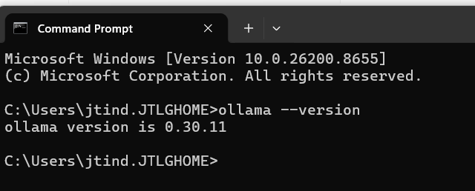
Richard Tindell

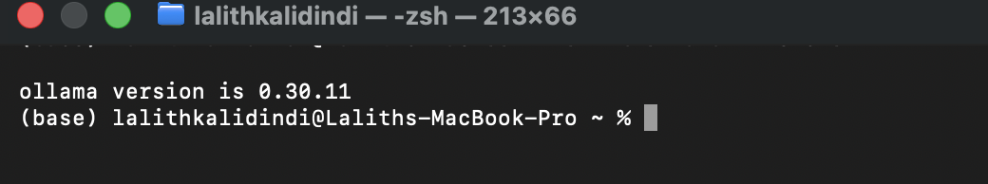LK Kalidindi

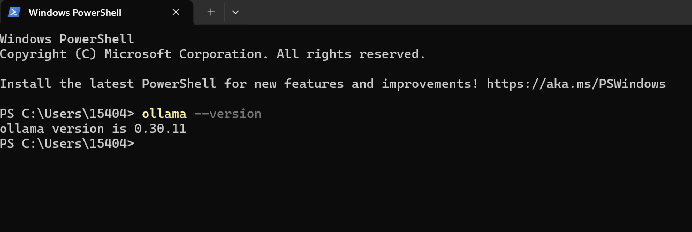
Saukhya Shrestha

Step 2:
Name | Source | License | Row Count | 1-sentence Justification
Cybersecurity_Phishing_FAQs | Self-Created Synthetic Data using AI | Open source | 161 | This dataset has fundamental cybersecurity FAQs dedicated with simple language for students inquiries in non-technical terms

Step 3
The most useful resource was the video explaining how to fine-tune a LLM by Warp.

LK- I have looked at the links that were provided in the document.
Saukhya – I confirm I have reviews Step 3 resources
Richard – I confirm I have reviewed Step 3 resources

Step 4: Model + Method
- Model: LLaMA 3.2 3B
- Method: LoRA; Hyperparamaters:
- Platform: Google Colab
- Training dataset file: cybersecurity_faqs.json
- Why? We chose the model because it was open-source and had good capabilities while requiring less computational power. For the task given, a complex model was not required, and this one had enough qualities that made it perfect.
Step 5:
Project Status Color: Green
The Project is moving really well; there are no issues at the moment.

